The founder of the Tomas Bata Regional Hospital is the Zlín Region
Supported by Norway Grants

“Increase in the level of comprehensive long-term monitoring of the neuromotor development of children with perinatal stress in the Zlín Region”

NF-CZ11-OV-1-010-2015

PRESS RELEASE

Perinatological care in TBRH will be improved with the arrival of 13 new devices acquired with the support of Norway Grants

Zlín – Thirteen new devices have been put into use in the neonatal, paediatric, ophthalmology and ENT departments in the Tomas Bata Regional Hospital (TBRH) in Zlín. The devices were acquired this year for almost CZK 10 million. They will be used to improve the level of perinatological care at the hospital. The Ministry of Finance of the Czech Republic approved the grant from Norway Grants to cover 60% of the total expenditure, with the hospital paying the remaining part from its own sources.
“The modernization of the perinatological centre was important. It was necessary to improve the quality of diagnostic and therapeutic care in the area of eye defects, congenital heart defects, heart rhythm disorders, pathological findings in the brain and abdominal cavity, and others. With the help of these modern devices, we can provide a timely and accurate diagnosis. Parents will also no longer need to bring their child to a remote hospital for an examination,” said Jozef Macko, Consultant Neonatal Department, TBRH.
The joint Paediatric and Neonatal Outpatient Department has now been equipped with a sonographic device which allows examinations of the brain, heart and urogenital tract. The Ophthalmology Department now has a retinal camera at its disposal, and the ENT Department a flexible rhino-laryngo video endoscope.
The project, entitled “Increase in the level of comprehensive long-term monitoring of the neuromotor development of children with perinatal stress in the Zlín Region,” also includes training for the nursing staff.
“The physiotherapists in the Rehabilitation Department have completed a Respiratory Physiotherapy course and a Developmental Rehabilitation course which uses Prechtl's method. This method determines or eliminates the development of cerebral palsy in a child with 96 percent accuracy. The examination is non-invasive, recognized worldwide and does not put the child under any stress. The application of the method on children with perinatal stress will bring TBRH up to international standards,” explained Jozef Macko.
Two doctors from the ENT Department undertook internships at the specialized department in the AUDIO-Fon Centre in Brno. “The internship focused on teaching and training the participants to evaluate examination results using an objective audiometer,” added Jozef Macko.
Since 1997, the Neonatal and Gynaecological-obstetric Department at TBRH has served as the Perinatological Centre for the Zlín Region. Every year, the Neonatal Department hospitalizes almost 350 newborns in the Resuscitation and Intensive Care Department and in the intermediate section. Approximately 2,500 children are born at TBRH annually, of which more than 12% are children with a low birth weight. Of this number, 80 – 90 children are born weighing less than 1,500 grams. In terms of the number of births, the Zlín Maternity Hospital and Neonatal Department are among the largest in the Czech Republic.

Appendix
List and photographs of the acquired devices
(PHOTO: K. Havlíková)

19/10/2016
Karla Havlíková
TBRH Press Spokeswoman
Tel. + 420 577 552 115, + 420 724 665 407
Supported by Norway Grants

“Increase in the level of comprehensive long-term monitoring
of the neuromotor development of children
with perinatal stress in the Zlín Region“

NF-CZ11-OV-1-010-2015

Appendix to the press release

List of acquired medical devices

Ophthalmology Department
- retinal camera
- indirect binocular ophthalmoscope
- hand-held portable slit lamp

ENT Department
- clinical device for examining otoacoustic emissions
- device for examining the evoked auditory potential of the brainstem
- clinical tympanometer
- hand-held tympanometer
- paediatric flexible rhino-laryngo video endoscope

Paediatric Department
- ECG
- BP holter monitor
- ECG holter monitor

Neonatal and paediatric Department
- sonographic device

Neonatal Department
- device for examining otoacoustic emissions - rescreening

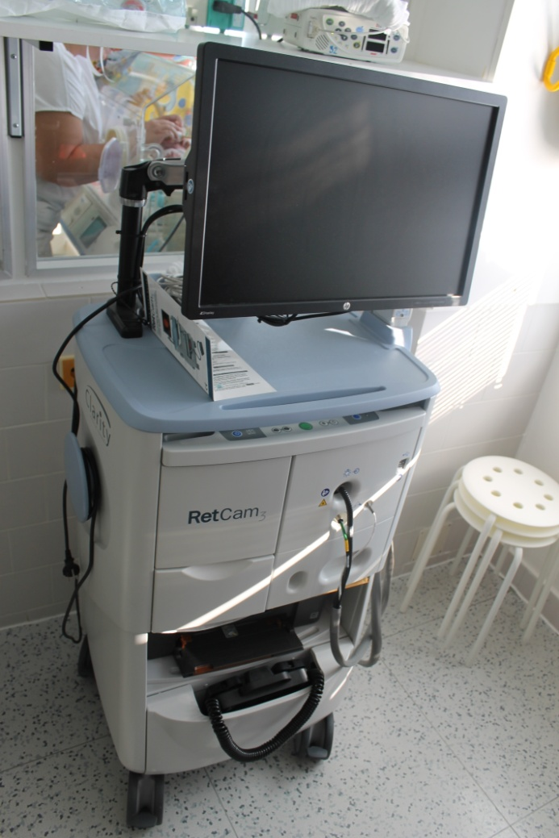
retinal camera
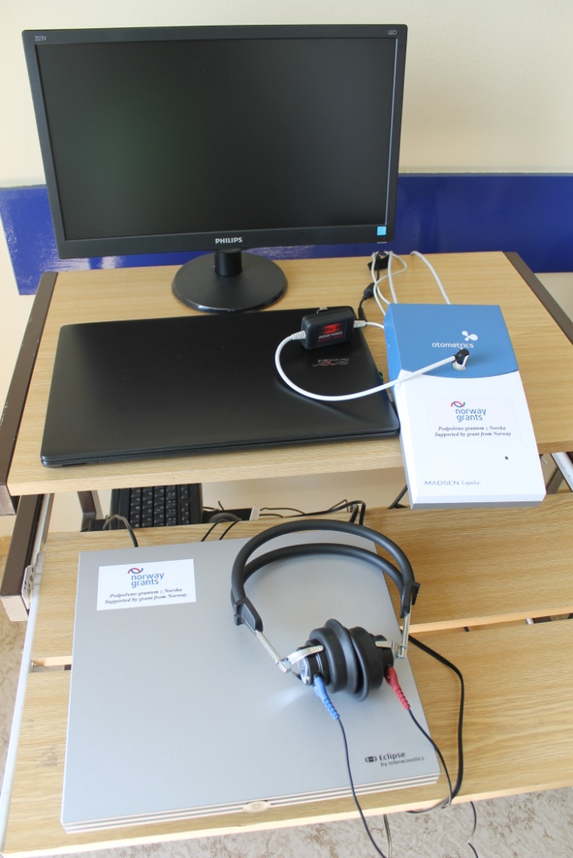
Up: clinical device for examining OAE
Down: device for examining the evoked auditory potential of the brainstem
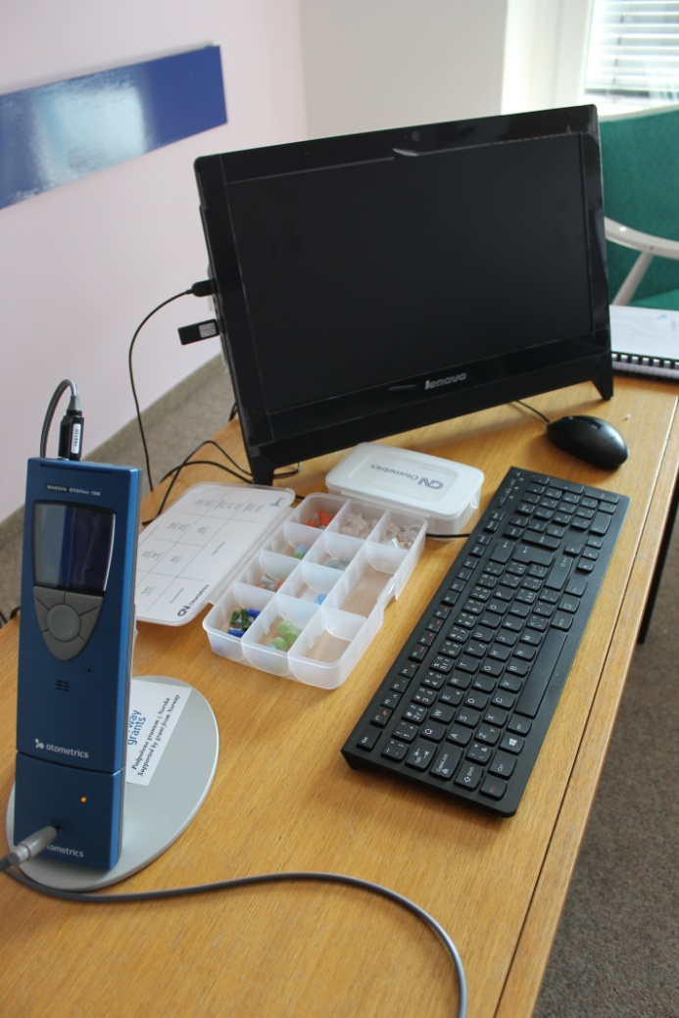
hand-held tympanometer
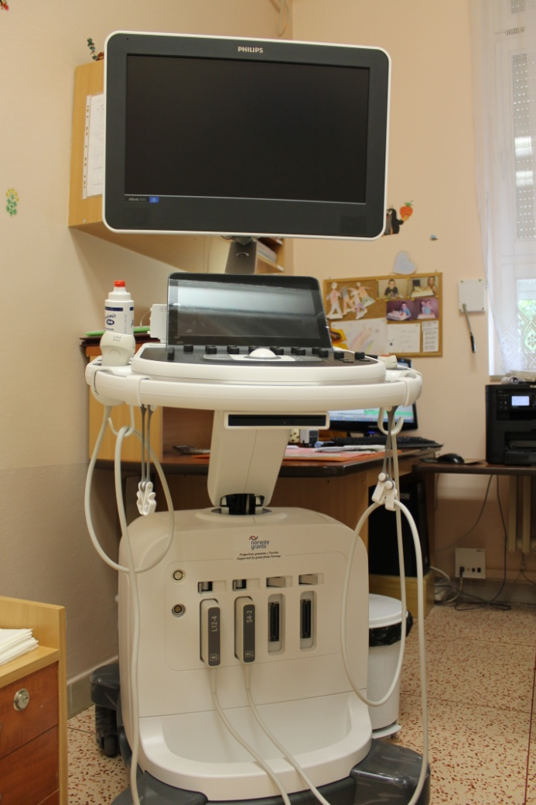
sonographic device

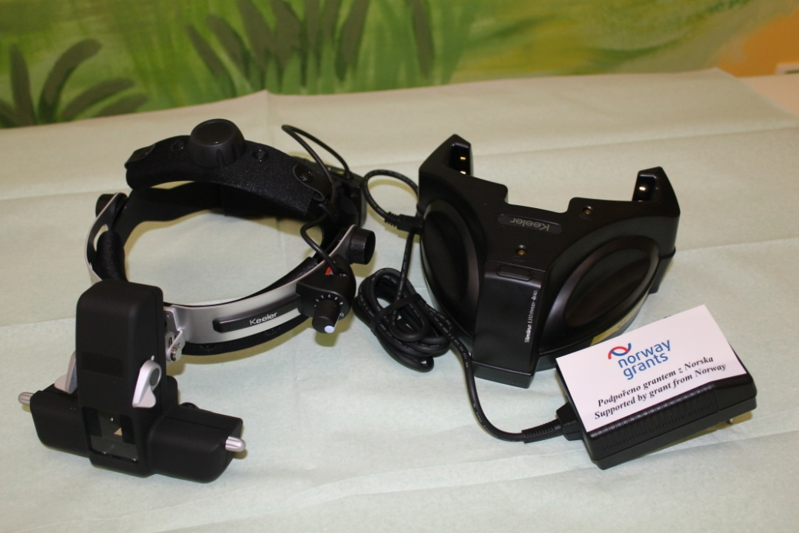
indirect binocular ophthalmoscope
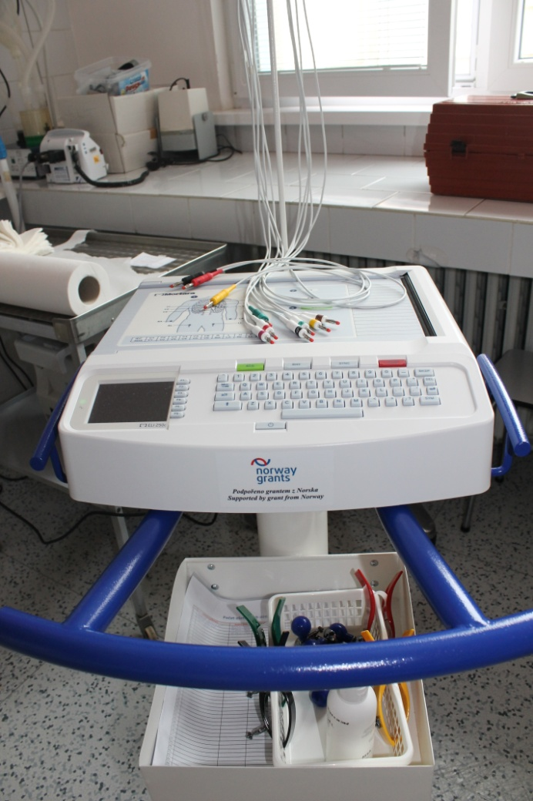
ECG

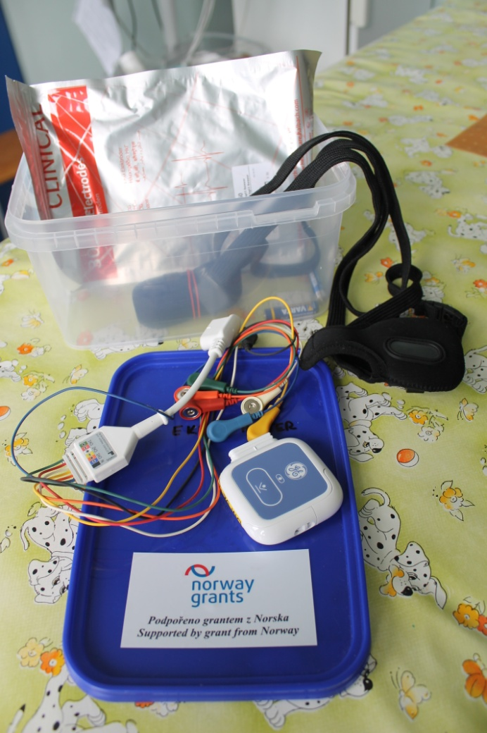
ECG holter monitor
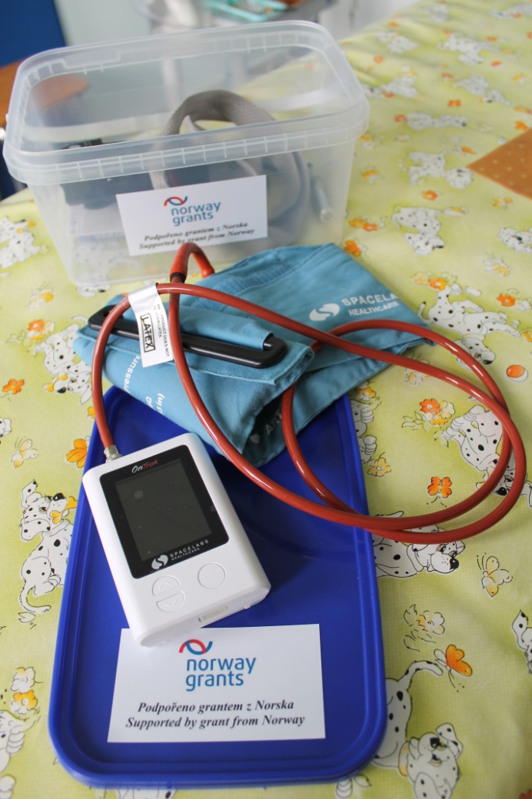
BP holter monitor

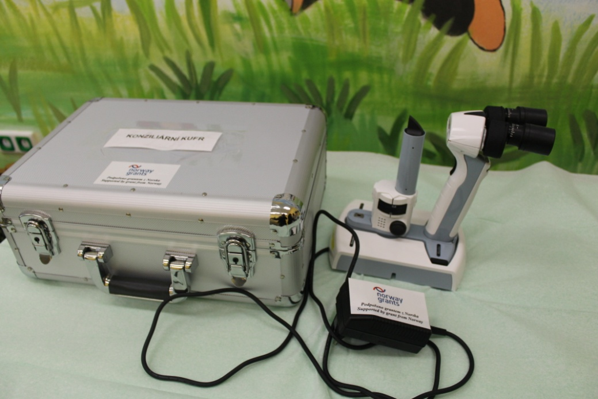
hand-held portable slit lamp
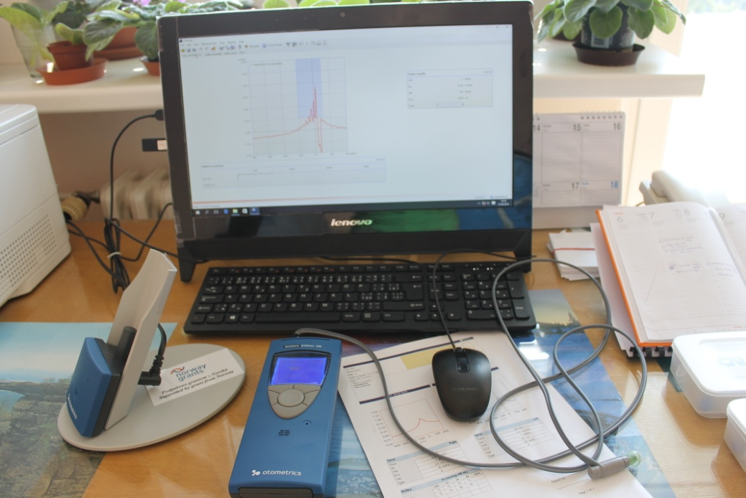
clinical tympanometer
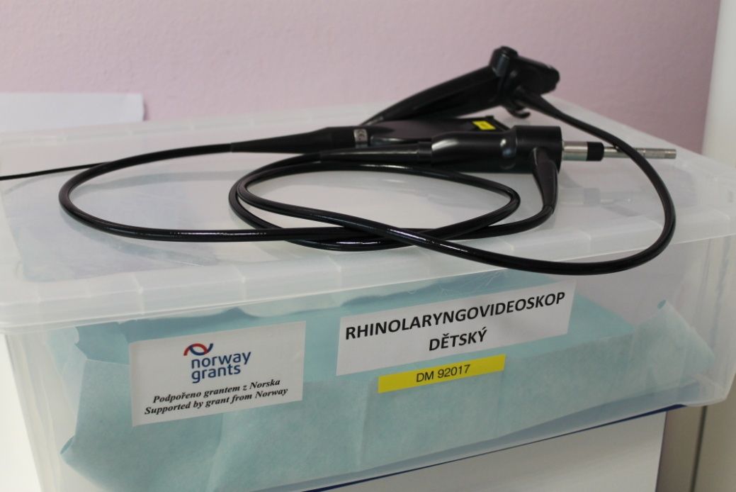
paediatric flexible rhino-laryngo video endoscope
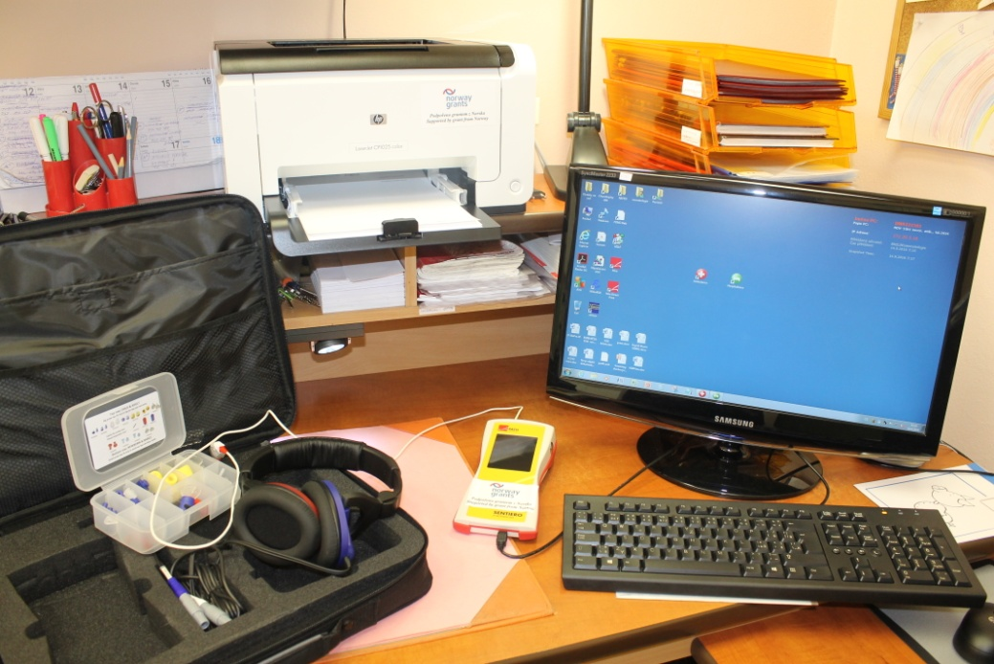
device for examining otoacoustic emissions - rescreening

