Current information about the project „Increase in the Level of Complex Long-term Monitoring of Neuromotoric Child Development with Perinatal Burden in Zlín Region“
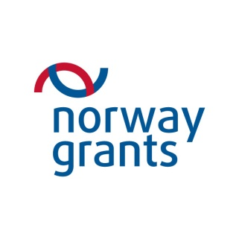 | Supported by grant from Norway

Current information during on the implementation of the project (as of 30. 6. 2016):
- Implementation of the project is extended to 4/2017
- The medical staff were trained (Prechtl methods course and course of respiratory physiotherapy)
- some equipment on which children are already investigated was delivered(eg. Children's flexible rhino-laryngo video endoscope, fundus camera, indirect binocular ophthalmoscope, portable slit lamp, ultrasound, ECG, ECG Holter, BP Holter), the other planned instruments should be delivered to 9/2016.

Photographs taken by devices
Fundus camera | Rhino-laryngo endoscope
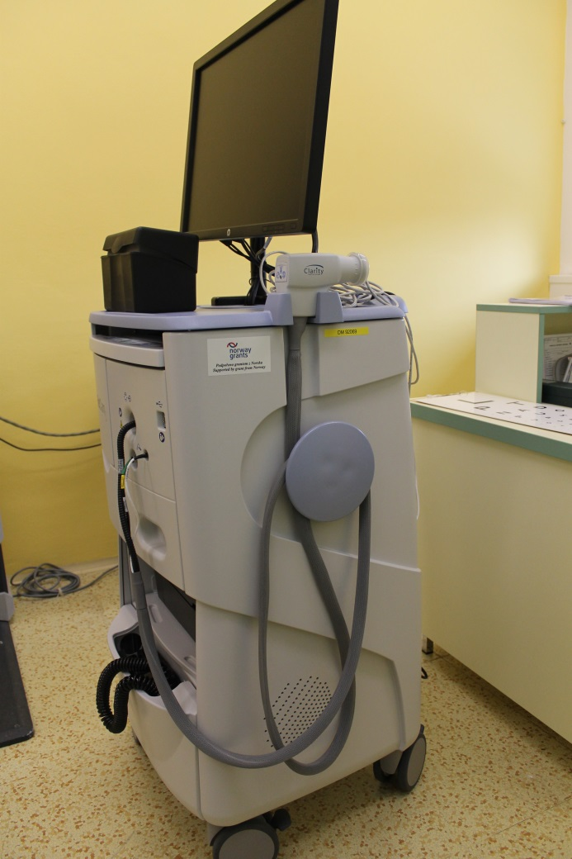 | 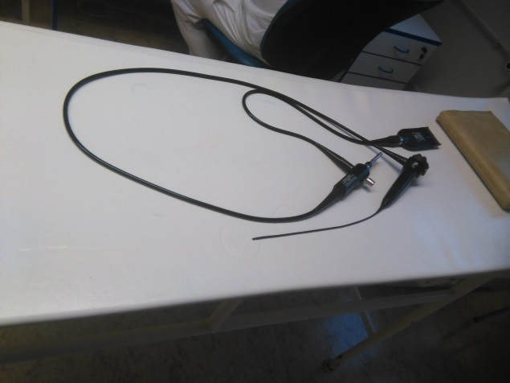
 | Portable slit lamp
 | 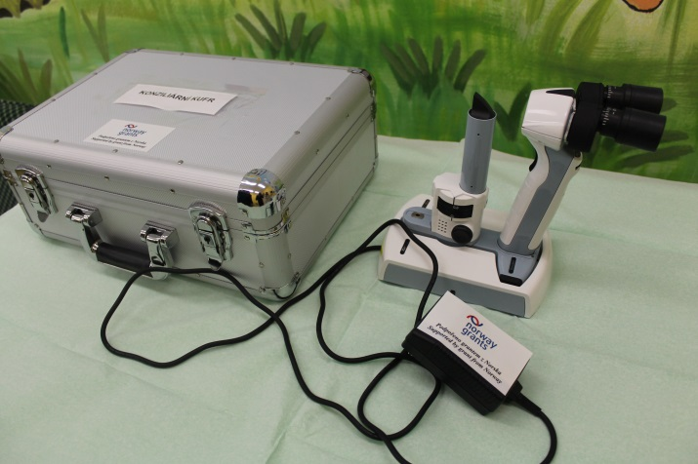

The project does not take place with the cooperation of the Donor State entities. Information about the project were published in the journal of the Grand Hospital, 6/2015.

